**16-BIT SUBTRACTION**  
  
  
**EXP NO: 6**  
  
**AIM:**To write an assembly language program to implement 16-bit subtraction using 8085  
processor.  
  
**ALGORITHM:**  
  
1)   Start the program by loading a register pair with address of 1st number.  
2)     Copy the data to another register pair.  
3)      Load the second number to first registre pair.  
4)     Subtract the two register pair contents.  
5)      Check for borrow.  
6)      Store the value of difference and borrow in memory locations.  
7)      End.  
  
  
   
  
  
**PROGRAM:**  
  
  
LHLD 2050

XCHG  
  
LHLD 2052

MVI C,00  
  
 MOV A, E  
  
SUB L  
  
 STA 2054  
  
MOV A, D  
  
SUB H  
  
STA 2055  
  
 HLT  
  
  
  
  
  
**INPUT:**

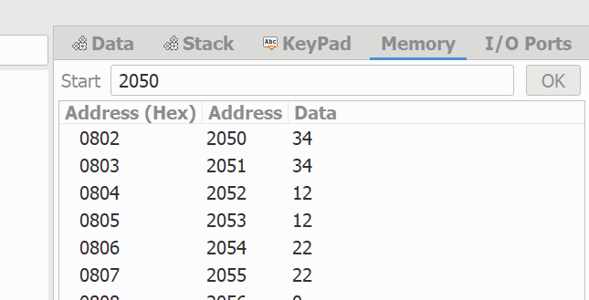  
  
  
  
  
  
  
  
  
**OUTPUT:**

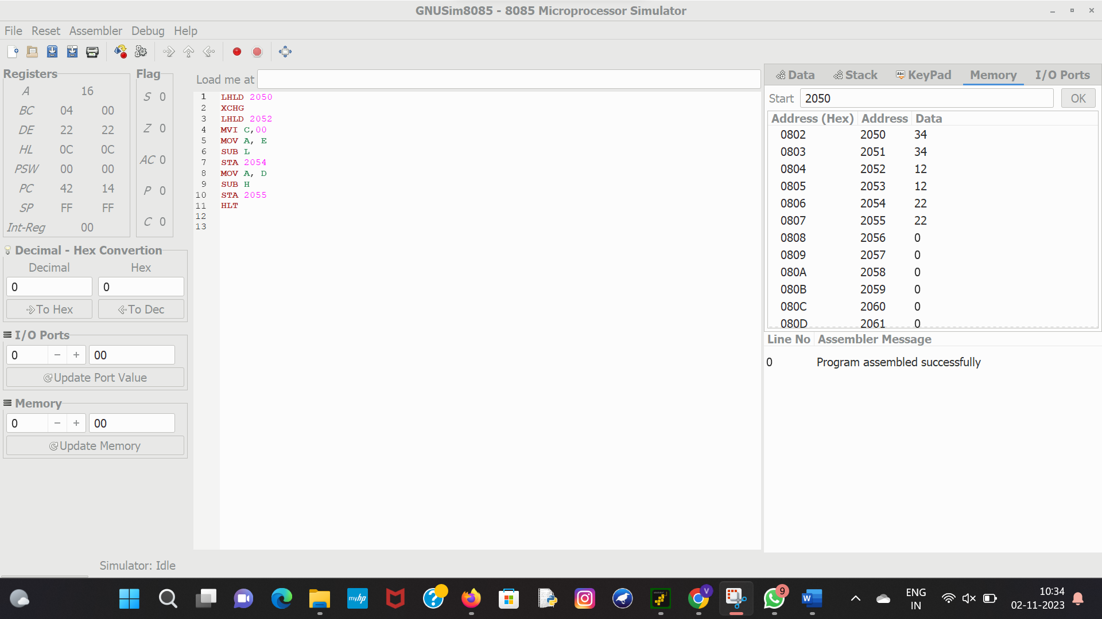  
  
  
  
  
  
  
  
  
**RESULT:**Thus the program was executed successfully using 8085  
processor simulator.